An Attention -Based Knowledge Tracing Framework For Personalized Learning System Using Cognitive Memory
Project Stage II Report
Submitted to


Jawaharlal Nehru Technological University, Hyderabad
In partial fulfilment of the requirements for the Award of the degree of
BACHELOR OF TECHNOLOGY
In
CSE (DATA SCIENCE)

by
BOMMISHETTI MOUNIKA (22VE1A6768) GUNDLA SREEJA (22VE1A6774)
MANNE SHANTI (22VE1A6793) NAGAVARAM SRI VARSHINI (22VE1A67A0)
Under the Guidance of
Dr. G. Naga Rama Devi Professor & HOD - CSE(DS)


An Attention -Based Knowledge Tracing Framework For Personalized Learning System Using Cognitive Memory
Project Stage II Report
Submitted to


Jawaharlal Nehru Technological University, Hyderabad
In partial fulfilment of the requirements for the Award of the degree of
BACHELOR OF TECHNOLOGY
In
CSE (DATA SCIENCE)

by
BOMMISHETTI MOUNIKA (22VE1A6768) GUNDLA SREEJA (22VE1A6774)
MANNE SHANTI (22VE1A6793) NAGAVARAM SRI VARSHINI (22VE1A67A0)
Under the Guidance of

Dr. G. Naga Rama Devi Professor & HOD - CSE(DS)




SREYAS INSTITUTE OF ENGINEERING AND TECHNOLOGY (UGC - AUTONOMOUS)
DEPARTMENT OF CSE (DATA SCIENCE)

CERTIFICATE

This is to certify that the Project Stage II Report on “AN ATTENTION- BASED KNOWLEDGE TRACING FRAMEWORK FOR PERSONALIZED LEARNING SYSTEM USING COGNITIVE MEMORY” Submitted by BOMMISHETTI MOUNIKA, GUNDLA SREEJA, MANNE SHANTI, NAGAVARAM SRI VARSHINI bearing Hall ticket
Numbers. 22VE1A6768, 22VE1A6774, 22VE1A6793, 22VE1A67A0 in partial fulfillment of the requirements for the award of the degree of Bachelor of Technology in CSE (DATA SCIENCE) from Jawaharlal Nehru Technological University, Kukatpally, Hyderabad for the academic year 2025-2026 is a record of bonafide work carried out by them under our guidance and Supervision.

Internal Guide Head of the Department

Dr. G. Naga Rama Devi Dr. G. Naga Rama Devi

Professor & HOD Professor

Project Co-Ordinator External Examiner Dr. G. Naga Rama Devi
Professor & HOD



SREYAS INSTITUTE OF ENGINEERING AND TECHNOLOGY (UGC – AUTONOMOUS)
DEPARTMENT OF CSE (DATA SCIENCE)

DECLARATION

We BOMMISHETTI MOUNIKA, GUNDLA SREEJA, MANNE SHANTI, NAGAVARAM SRI VARSHINI, bearing 22VE1A6768, 22VE1A6774,
22VE1A6793, 22VE1A67A0 hereby declare that the Project title “AN ATTENTION - BASED KNOWLEDGE TRACING FRAMEWORK FOR PERSONALIZED
LEARNING SYSTEM USING COGNITIVE MEMORY” done by us under the guidance of Dr. G. Naga Rama Devi, Professor and Head of the Department, CSE (DS), which is submitted in the partial fulfillment of the requirement for the award of the B. Tech degree in CSE (Data Science) at Sreyas Institute of Engineering & Technology for Jawaharlal Nehru Technological University, Hyderabad is our original work.

BOMMISHETTI MOUNIKA (22VE1A6768) GUNDLA SREEJA (22VE1A6774)
MANNE SHANTI (22VE1A6793) NAGAVARAM SRI VARSHINI (22VE1A67A0)

ACKNOWLEDGEMENT

We would like to express my sincere gratitude to the Management of Sreyas Institute of Engineering and Technology (UGC–Autonomous) for providing excellent infrastructure and laboratory facilities, which significantly contributed to the successful completion of this project.
We are deeply thankful to our respected Principal, Dr. C. Udaya Kiran, for his constant encouragement and support, which motivated me to complete this project successfully.
We express our profound gratitude to my project supervisor, Dr. G. Naga Rama Devi, Professor and Head of the Department, CSE (DS), for the valuable guidance, continuous support, and constructive suggestions provided throughout the course of this project. We are grateful for the freedom of thought, approachability, and encouragement extended by her, which made this work a rewarding learning experience.
We extend our sincere thanks to Dr. G. Naga Rama Devi, Professor and Head of the Department, CSE (DS), for her constant motivation, encouragement, and support at every stage of this endeavor. I am highly indebted for the guidance and inspiration provided.
We also express my heartfelt thanks to all the faculty members of the Department of CSE (DS) for their valuable suggestions, timely guidance, and technical knowledge, which greatly enhanced the quality of this project.
Finally, we would like to thank my friends and family for their constant encouragement, cooperation, and moral support, without which this project would not have been possible.

BOMMISHETTI MOUNIKA (22VE1A6768) GUNDLA SREEJA (22VE1A6774)
MANNE SHANTI (22VE1A6793) NAGAVARAM SRI VARSHINI (22VE1A67A0)

ABSTRACT

Personalized learning isn’t just a nice-to-have in modern educational tech—it’s pretty much a must, since every student thinks and learns a little differently. But here’s the thing: most traditional intelligent tutoring systems don’t really keep track of a student’s progress over time. They struggle to adjust their teaching style acro ss different sessions, so students can end up repeating material or missing key connections. At that our paper speaks its part. We discuss the Differentiation: our Learning Tutor with the Cognitive Memory. It’s an “AI -infused learning”. A machine learning powered platform designed to provide all the students with personal and ongoing assistance. support. Substantially, this model involves a very huge language model. and coupled with a memory structure which works like a human memory. the brain, having short-time, long-time and reflective memory. This enables it to recollect the way in which each student learns and hence it is able to trace their develop and the strategies of change as they expand. We trained the system on real student interaction data from the ASSISTments dataset. It watches how students answer questions, then adapts its explanations, practice problems, and feedback in real time. The memory- augmented knowledge tracing keeps tabs on what students know and how their skills develop, so the tutor can really zero in on what each learner needs. When we put the system to the test, using standard metrics like accuracy, precision, recall, and F1
-score, it hit an overall accuracy of 84.7%. That’s a solid jump compared to older tutoring models that don’t use cognitive memory. Adding cognitive memory makes personalization and learning continuity way better. The system not only helps students learn more effectively but also scales up for bigger classrooms or platforms. It’s a new step forward for adaptive learning technology.

Keywords— Personalized learning, Intelligent tutoring systems, Cognitive memory, Personalized Learning Tutor, Large language model, Knowledge tracing, ASSISTments

PAGE INDEX

S.NO |  | TABLE OF CONTENTS | PAGE NO.
1 |  | INTRODUCTION | 1-8
 | 1.1 | OVERVIEW OF THE PROJECT | 1
 | 1.2 | MOTIVATION | 2
 | 1.3 | OBJECTIVE | 3
 | 1.4 | SCOPE | 4
 | 1.5 | OUTLINE | 5-8
2 |  | LITERATURE SURVEY | 9-12
3 |  | PROPOSED SYSTEM | 13-21
 | 3.1 | EXISTING SYSTEM | 13-14
 | 3.2 | PROPOSED SYSTEM | 14-15
 | 3.3 | SOFTWARE REQUIREMENTS  SPECIFICATION | 16-19
 | 3.4 | CONCLUSION | 20-21
4 |  | SYSTEM DESIGN | 22-28
 | 4.1 | IMPORTANCE OF DESIGN | 22-23
 | 4.2 | SYSTEM ARCHITECTURE | 24
 | 4.3 | UML DIAGRAMS | 25-28
5 |  | IMPLEMENTATION | 29-41
 | 5.1 | MODULE | 29

 | 5.2 | DATA PREPROCESSING | 30
 | 5.3 | MODEL ARCHITECTURE — SAKT | 30
 | 5.4 | DATASET AND BATCHING | 31
 | 5.5 | TRAINING — HYPERPARAMETERS &  OBSERVED RESULTS | 31
 | 5.6 | CODE | 32-40
 | 5.7 | ATTENTION-BASED KNOWLEDGE  TRACING MODEL DEFINITION | 41
 | 5.8 | MODEL COMPILATION AND  OPTIMIZATION | 41
6 |  | TESTING AND VALIDATION | 42-44
 | 6.1 | IMPORTANCE OF TESTING | 42
 | 6.2 | TYPES OF TESTING | 43
 | 6.3 | TEST PLAN | 44
 | 6.4 | TEST STRATEGY | 44
7 |  | RESULTS AND OUTPUT SCREENS | 45-59
 | 7.1 | SNAPSHOTS | 45-50
 | 7.2 | SYSTEM OUTPUT SUMMARY | 50
8 |  | CONCLUSION | 51
 |  | FUTURE WORK | 52
 |  | REFERENCES | 53-54

FIGURE INDEX

FIG.NO/TAB.N O | LIST OF FIGURES AND TABLES | PAGE NO.
Fig 4.3.1 | USE CASE DIAGRAM | 25
Fig 4.3.2 | ACTIVITY DIAGRAM | 26
Fig 4.3.3 | SEQUENCE DIAGRAM | 27
Fig 4.4.4 | DEPLOYMENT DIAGRAM | 28

SCREENSHOTS INDEX

SCREENSHOT. NO | LIST OF SCREENSHOTS | PAGE.  NO
Fig 7.1.1 | SNAPSHOTS OF DATASET AFTER PRE- PROCESSING | 45
Fig 7.1.2 | MODEL EVALUATION RESULTS | 46
Fig 7.1.3 | TRAINING PERFORMANCE VISUALIZATION | 47
Fig 7.1.4 | MODEL ACCURACY VISUALIZATION | 48
Fig 7.1.5 | ROC CURVE ANALYSIS | 48
Fig 7.1.6 | COGNITIVE MEMORY- DRIVEN PERSONALIZED LEARNING TUTOR | 49
Fig 7.1.7 | EXPLAINABLE COGNITIVE LEARNER MODELING DASHBOARD | 50

CHAPTER – 1 INTRODUCTION

OVERVIEW OF THE PROJECT

Education has undergone a massive transformation in recent years due to the rapid advancement of digital technologies and artificial intelligence. Traditional classroom-based teaching methods, which follow a uniform approach for all learners, are increasingly being replaced by online learning platforms, intelligent tutoring systems, and AI-driven educational tools. While these technologies have improved accessibility and flexibility in learning, they still fail to address one of the most critical challenges in education — individual differences in learning pace, understanding, and cognitive ability.
Most learners do not learn in the same way or at the same speed. Some students grasp concepts quickly, while others require repeated explanations, additional examples, or alternative teaching strategies. Conventional e-learning systems and standard AI chatbots provide static content and generic responses, treating all learners uniformly. These systems lack the ability to remember previous learning interactions, track long-term progress, and adapt teaching strategies based on a learner’s evolving knowledge state. As a result, learning becomes fragmented, repetitive, and less effective over time.
The Personalized Learning Tutor with Cognitive Memory project is designed to overcome these limitations by introducing an intelligent tutoring system that behaves more like a human tutor. A human tutor remembers a student’s past performance, understands their strengths and weaknesses, adapts explanations accordingly, and continuously refines teaching strategies. The goal of this project is to replicate these human-like teaching capabilities using artificial intelligence, machine learning, and cognitive memory modeling.
At the core of this project is the concept of personalized learning, where instructional content, assessments, and feedback are dynamically tailored to the needs of each individual learner. The proposed system integrates Large Language Models (LLMs) with a cognitive memory architecture that enables the tutor to retain both short-term and long-term learning information.

MOTIVATION

Education is one of the most critical pillars of societal development, yet traditional learning systems often fail to address the diverse needs of individual learners. In conventional classroom environments, teachers are required to instruct a large number of students using a fixed curriculum and uniform teaching methods. This approach assumes that all learners have the same cognitive abilities, learning speed, and understanding capacity, which is rarely the case in real-world scenarios With the rise of online education platforms and digital learning tools, accessibility to education has improved significantly. However, most e- learning systems still follow static content delivery models interactions or learning history. Each session is treated independently, causing repetitive explanations, loss of context, and inefficient learning progression. One of the major motivational factors behind this project is the absence of long-term personalization in existing intelligent tutoring systems. A human tutor naturally remembers a student’s past performance, identifies recurring mistakes, and adapts teaching strategies accordingly. In contrast, most digital learning systems lack memory mechanisms that can store and utilize historical learner data. This gap results in fragmented learning experiences and prevents the system from providing meaningful, adaptive support over time. Another key motivation arises from the growing complexity of learning requirements in technical and academic fields. Subjects such as mathematics, computer science, and data science require cumulative understanding, where new concepts build upon previously learned material. Without continuous tracking of learner knowledge and misconceptions, students often develop gaps that go unnoticed until advanced stages. An intelligent system that can monitor learning progression, detect weak areas early, and provide targeted remediation is essential to address this challenge.

OBJECTIVE
The primary objective of the Personalized Learning Tutor with Cognitive Memory project is to design and develop an intelligent tutoring system that delivers adaptive, continuous, and personalized learning experiences by integrating artificial intelligence, cognitive memory modeling, and data-driven analytics. The project aims to move beyond conventional e-learning platforms and stateless AI chatbots by creating a system that can

remember learner interactions, understand individual learning patterns, and evolve its teaching strategies over time.
A key objective of this project is to implement a cognitive memory–driven tutoring framework that closely resembles human learning behavior. The system is designed to maintain both short- term and long-term memory of learner interactions. Short-term memory enables the tutor to understand the current learning context and respond coherently within a session, while long-term memory preserves historical performance data, topic-wise progress, and learning trends across multiple sessions. This ensures continuity in learning and prevents repetitive or disconnected instructional experiences.
Another important objective is to leverage Large Language Models (LLMs) to facilitate natural, conversational interaction between the learner and the tutor. The system aims to generate clear, human-like explanations, answer queries in an intuitive manner, and guide learners interactively, thereby improving engagement and comprehension. By combining LLMs with memory mechanisms, the tutor is capable of delivering context-aware responses that reflect prior learning history.
The project also aims to achieve personalized learning through adaptive content delivery. By continuously analyzing learner responses and performance metrics, the system dynamically adjusts explanations, examples, and difficulty levels to suit individual learner needs. This objective ensures that learners receive customized instruction aligned with their learning pace, strengths, and weaknesses rather than a generic, one-size-fits-all approach.
An additional objective of the project is to incorporate reflective learning mechanisms that analyze learner mistakes and misconceptions over time.

SCOPE
The scope of the Personalized Learning Tutor with Cognitive Memory project encompasses the design, development, and evaluation of an intelligent tutoring system that provides adaptive, personalized, and continuous learning support using artificial intelligence and cognitive memory modeling. The project focuses on addressing the limitations of traditional e- learning platforms by introducing a memory-driven framework capable of understanding and evolving with individual learners over time. The proposed system is designed to function as a virtual learning assistant that can be applied across a wide range of educational contexts.

It can support academic learning in subjects that require cumulative understanding, such as mathematics, computer science, data science, and other technical or theoretical domains.
By tracking learner progress and maintaining contextual continuity, the tutor can guide learners through complex concepts in a structured and personalized manner. The scope of this project includes the implementation of cognitive memory mechanisms, specifically short- term memory, long-term memory, and reflective memory. These memory layers enable the system to store learner interaction history, analyze performance trends, and adapt teaching strategies based on past learning behavior. The project focuses on addressing the limitations of traditional e-learning platforms by introducing a memory-driven framework capable of understanding and evolving with individual learners over time This ensures that the tutor does not treat each session independently but rather as part of a continuous learning journey.
Another important aspect within the scope of the project is the integration of Large Language Models (LLMs) for natural language interaction. The system is capable of engaging learners in conversational learning, answering questions, explaining concepts, and providing feedback in a human-like manner. Short-term memory enables the tutor to understand the current learning context and respond coherently within a session, while long-term memory preserves historical performance data, topic-wise progress, and learning trends across multiple sessions. This interaction is enhanced through Retrieval-Augmented Generation (RAG), which ensures that all generated responses are grounded in reliable academic content. The project scope also covers the use of machine learning and knowledge tracing techniques to model learner behavior and predict learning outcomes. By combining LLMs with memory mechanisms, the tutor is capable of delivering context- aware responses that reflect prior learning history.
By training the system on real-world educational datasets such as ASSISTments 2009, the tutor can analyze sequential learner interactions and estimate knowledge mastery levels. This enables proactive adaptation of learning content and assessments based on predicted learner needs. From a functional perspective, the system includes adaptive assessment and learning analytics capabilities. It dynamically generates quizzes and practice exercises, evaluates learner responses in real time, and produces detailed progress reports using performance metrics such as accuracy y, precision, recall, F1-score, and learning improvement trends.

OUTLINE

Introduction
The rapid advancement of digital technologies and artificial intelligence has brought a significant transformation in the field of education and learning systems. Traditional classroom-based learning models and one-size-fits-all digital platforms often fail to address the diverse learning needs, pace, and cognitive abilities of individual learners. As learners differ in prior knowledge, learning speed, retention capacity, and conceptual understanding, there is an increasing demand for intelligent systems that can adapt learning content dynamically. This need has led to the emergence of personalized learning systems that aim to enhance learner engagement, knowledge retention, and overall learning effectiveness. Artificial Intelligence has played a crucial role in reshaping modern educational platforms by enabling adaptive content delivery, automated assessment, and intelligent feedback mechanisms. However, many existing AI-based tutoring systems still operate on static personalization techniques, where recommendations are based only on recent performance or predefined rules. Such systems lack the ability to retain long-term learning behavior and often fail to model the learner’s cognitive state accurately. As a result, learners may face repetitive content, poorly timed revisions, or gaps in conceptual understanding. To overcome these limitations, the concept of cognitive memory has gained importance in intelligent tutoring systems. Cognitive memory models aim to simulate human-like memory behavior by maintaining short-term and long-term knowledge representations. Short-term memory captures recent learning interactions, while long-term memory stores historical learning patterns, strengths, and weaknesses. By integrating cognitive memory, a learning system can make more informed decisions regarding what to teach, when to revise, and how to personalize explanations for each learner. The Personalized Learning Tutor with Cognitive Memory proposed in this project focuses on addressing these challenges by combining adaptive learning strategies with memory-driven intelligence. The system continuously tracks learner interactions, evaluates concept mastery levels, and predicts forgetting risks to schedule timely revisions. Instead of treating each learning session independently, the system builds a continuous learning profile for the learner, enabling consistent personalization across multiple sessions.

    - Literature Survey
The literature survey provides a comprehensive review of existing learning systems, intelligent tutoring platforms, and adaptive educational technologies that have been developed over the years. Traditional learning systems primarily rely on instructor-driven or static content delivery models, where all learners are exposed to the same curriculum irrespective of their individual learning abilities. While such systems are simple to implement, they fail to address differences in learning pace, prior knowledge, and cognitive capacity, leading to reduced learner engagement and suboptimal learning outcomes.
With the advancement of digital education, several e-learning platforms have been introduced to provide flexible and self-paced learning opportunities. These platforms offer recorded lectures, quizzes, and basic assessments. However, most of these systems lack true personalization and perate using predefined rules or linear progression paths. Learners are often required to manually decide what to study next, which can result in inefficient learning and poor concept retention.
    - Existing System
This section describes the currently available learning systems and AI-based tutoring platforms. It explains how most existing systems rely on static content delivery, rule-based responses, and limited personalization. The lack of long-term memory, contextual awareness, and adaptive feedback mechanisms in these systems is discussed. The section highlights issues such as repetitive learning, poor engagement, and disconnected learning sessions. These limitations motivate the need for an improved solution.
    - Proposed System
This section explains the proposed Personalized Learning Tutor with Cognitive Memory in detail. It describes how the system integrates cognitive memory layers, Large Language Models, and retrieval-augmented generation to deliver adaptive learning. The section outlines how learner interactions are stored, analyzed, and used to personalize explanations, examples, and assessments. It also explains how the system ensures learning continuity across multiple sessions

    - Advantages
This section highlights the major advantages of the proposed system. It explains how personalized learning paths improve learner engagement and knowledge retention. The role of cognitive memory in avoiding repetitive instruction and supporting continuous learning is discussed. The section also emphasizes the system’s scalability, accuracy, and adaptability. it explains how real-time feedback and analytics enhance overall learning experience.
    - System Architecture
This section provides an overview of the system architecture and its major components. It describes the interaction between the user interface, learning model, cognitive memory module, knowledge retrieval system, and database. The flow of data between different modules is explained in a high-level manner. The section highlights how modular design improves system maintainability and scalability. It serves as a foundation for detailed design explanations in later sections.
    - Software and Tools
This section lists and briefly explains the software tools, programming languages, and frameworks used in the project. It includes details about Python, machine learning libraries, web development frameworks, and database technologies. The purpose of each tool in system development and deployment is described. The section also highlights the use of APIs and external libraries. This ensures clarity regarding the technical environment of the project.
    - Implementation
This section gives an overview of the implementation process followed in the project. It explains the steps involved in data preprocessing, model training, integration of cognitive memory, and system deployment. The section also mentions how the learning model is evaluated using performance metrics. It provides a brief understanding of how theoretical concepts are translated into a working system. Detailed implementation aspects are covered in later chapters.

    - Output
This section presents a detailed description of the outputs produced by the Personalized Learning Tutor with Cognitive Memory after the successful execution of all system modules. The output reflects the practical working of the proposed system and demonstrates how artificial intelligence, cognitive memory, and adaptive learning techniques work together to enhance the learning experience. The outputs serve as concrete evidence of system functionality, accuracy, and effectiveness. The primary output of the system includes learner performance predictions generated using knowledge tracing and machine learning models. Based on historical learner interactions, the system predicts whether a learner will correctly answer future questions. These predictions are evaluated using standard classification metrics such as accuracy, precision, recall, and F1-score. The results indicate improved prediction capability compared to traditional learning systems, validating the effectiveness of cognitive memory and attention-based modeling. Another important output of the system is the generation of adaptive learning content. The tutor dynamically provides personalized explanations, hints, and practice questions based on the learner’s current knowledge state and past performance. Unlike static systems, the output varies from learner to learner, ensuring individualized learning paths. This adaptability improves learner engagement and prevents repetitive or irrelevant instruction.
The system also produces visual analytical outputs such as confusion matrices, ROC curves, training and validation performance graphs, and progress dashboards. These visualizations help in understanding the learning model’s behavior, prediction accuracy, and generalization capability. Learners and evaluators can clearly observe improvement trends, topic-wise mastery levels, and areas requiring additional attention. In addition to learner-facing outputs, the system generates session-wise and cumulative learning reports. These reports summarize learner activity, performance trends, and cognitive memory updates over time. Such outputs are useful for monitoring long-term progress and for future enhancement of learning strategies. The memory-driven reporting mechanism ensures continuity and reflects the learner’s complete learning journey rather than isolated sessions. The output further includes system logs and response records, which store interaction details, prediction results, and memory updates.

CHAPTER-2 LITERATURE SURVEY

The evolution of Intelligent Tutoring Systems (ITS) has significantly transformed the way personalized education is delivered through digital platforms. Traditional educational systems generally follow a uniform teaching approach, where identical instructional material is provided to all learners regardless of their individual learning pace, background knowledge, or cognitive ability. However, research has consistently shown that learners exhibit diverse cognitive patterns, engagement levels, and retention capabilities. This limitation of one-size- fits-all instruction led to the development of adaptive and data-driven tutoring systems. Early research in intelligent tutoring systems focused on integrating assessment with instruction to better understand student learning behavior. Feng, Heffernan, and Koedinger [1] proposed an online tutoring system that continuously assessed student knowledge while simultaneously providing instructional support. Their approach emphasized the importance of real-time feedback and adaptive problem selection. By blending assessment into regular learning activities, the system was able to build a clearer understanding of student mastery levels. This work laid the foundation for modern adaptive learning environments, where every student interaction contributes to personalized learning pathways.

The ASSISTments ecosystem introduced by Heffernan and Heffernan [2] further strengthened research in educational data mining. ASSISTments serves as both a tutoring platform and a research environment, allowing large-scale data collection from real classroom settings. The platform enabled minimally invasive experimentation while gathering detailed interaction logs such as timestamps, student responses, hints requested, and skill mappings. The ASSISTments 2009 dataset became widely adopted in knowledge tracing research due to its rich sequential interaction data. This dataset provided the basis for developing and evaluating predictive models that estimate student performance and knowledge states over time.

Student modeling saw a major breakthrough with the introduction of Deep Knowledge Tracing (DKT) by Piech et al. [3]. DKT utilized Long Short-Term Memory (LSTM) networks to model the sequential learning process of students. Unlike traditional Bayesian Knowledge

Tracing methods, DKT captured complex temporal dependencies between student responses. This deep learning-based approach significantly improved prediction accuracy and demonstrated that neural networks can effectively learn patterns from educational sequences. However, DKT mainly focused on short-term learning dynamics and did not explicitly model long-term memory retention or forgetting mechanisms.

Baker and Inventado [4] provided a comprehensive overview of Educational Data Mining (EDM) and Learning Analytics. Their survey highlighted various data-driven approaches used to analyze student learning patterns, engagement levels, and academic performance. The authors emphasized the need for scalable, interpretable, and robust models that can operate effectively across diverse educational settings. Their work reinforced the idea that adaptive systems should not only predict student performance but also provide meaningful insights for instructional improvement. With advancements in neural architectures, attention mechanisms began to replace traditional recurrent models in many domains. Attention-based learning allows models to selectively focus on relevant parts of input sequences. Although originally applied in natural language processing, attention mechanisms later influenced educational modeling techniques. The introduction of Self- Attentive Knowledge Tracing (SAKT) demonstrated that attention-based architectures can outperform recurrent networks by better capturing relationships between past student interactions. SAKT improved interpretability and computational efficiency while maintaining high prediction performance.

In parallel, research into large language models (LLMs) revealed their ability to understand and generate human-like responses. Brown et al. [5] demonstrated few-shot learning capabilities using large transformer-based models. While not specifically targeted toward tutoring systems, this work showcased the potential of conversational AI in adaptive education. However, LLM-based systems often lack persistent memory structures to track long-term learner progress across sessions. Recognizing this limitation, Wang et al. [6] proposed incorporating cognitive memory mechanisms into knowledge tracing models. Their research integrated short-term and long-term memory representations to better reflect human learning processes. By modeling forgetting curves and reinforcement effects, their approach improved prediction stability and continuity across multiple learning sessions.

This memory-based modeling directly influenced the cognitive memory framework adopted in the proposed system. Furthermore, D’Mello and Graesser [7] explored the role of emotional states, particularly confusion, in the learning process. Their findings suggested that temporary confusion can enhance learning when managed appropriately. This implies that intelligent tutoring systems must go beyond binary correctness evaluation and adapt explanations dynamically according to learner state.

Exercise-Aware Knowledge Tracing (EKT), introduced by Liu et al. [8], enhanced predictive performance by incorporating exercise-level contextual features such as difficulty and skill embeddings. By combining student history with problem characteristics, EKT achieved improved contextual awareness and interpretability. From the existing literature, it is evident that significant advancements have been made in adaptive tutoring, sequential modeling, and performance prediction.

However, most traditional systems either focus solely on prediction accuracy or lack integration of long-term cognitive memory modeling. Additionally, many systems do not provide transparent adaptive decision mechanisms that explain why a particular question is selected. The proposed Personalized Learning Tutor addresses these research gaps by integrating Self- Attentive Knowledge Tracing (SAKT) with a structured cognitive memory framework consisting of short-term memory, long-term memory, and forgetting risk estimation.

Unlike earlier systems, the proposed approach not only predicts student responses but also adapts question selection and feedback dynamically based on evolving mastery levels. By combining attention-based deep learning with cognitive memory modeling, the system ensures personalized, continuous, and explainable learning support.

Thus, the literature survey demonstrates the progression from assessment-driven tutoring systems to deep learning-based knowledge tracing and memory-augmented adaptive systems. Building upon these foundational works, the present system advances personalized learning by integrating attention mechanisms with cognitive memory modeling in a unified framework.

In addition to performance prediction, another critical aspect observed in prior research is the challenge of maintaining learning continuity across multiple sessions. Many knowledge tracing models reset or treat sessions independently, which limits their ability to track gradual concept mastery over longer periods. Real-world learning, however, is cumulative and influenced by reinforcement, forgetting, and revision cycles. Without modeling these cognitive processes, adaptive systems may fail to provide consistent personalization. Therefore, incorporating memory-aware mechanisms becomes essential for creating intelligent tutors that mirror human learning behavior.

Moreover, while several existing systems achieve high prediction accuracy, they often lack interpretability and transparency. Modern educational platforms require explainable decision- making, especially when deployed in real classrooms. Teachers and learners benefit from understanding why a particular question is recommended or why additional practice is scheduled.

Attention-based models such as SAKT improve interpretability by identifying which past interactions influence current predictions. When combined with cognitive memory modeling, the system not only predicts outcomes but also explains adaptive decisions through measurable factors such as mastery gap and forgetting risk.

Another important observation from the literature is the growing need for scalable and user- friendly educational systems. Earlier research focused heavily on backend modeling without providing interactive graphical interfaces. However, practical deployment in educational environments requires intuitive user interfaces that allow real-time interaction, feedback visualization, and performance monitoring.

Integrating deep learning models with application frameworks enables adaptive tutoring systems to move beyond theoretical research and into practical implementation. This transition from model- centric systems to full-stack personalized learning platforms represents a significant step toward real-world adoption.

CHAPTER-3 PROPOSED SYSTEM

EXISTING SYSTEM

In the existing educational environment, learning systems primarily rely on traditional classroom-based teaching and basic digital learning platforms. These systems follow a standardized curriculum delivery approach, where the same content and teaching methods are applied to all learners regardless of their individual learning abilities, pace, or prior knowledge. Even though online learning platforms have increased accessibility, they largely provide static content such as recorded lectures, documents, and predefined quizzes. Some systems incorporate basic intelligent tutoring features using rule-based logic or simple machine learning models. These systems may adjust question difficulty based on recent learner performance, but they fail to maintain long-term learner context. Most existing systems treat each learning session independently, resulting in repeated explanations and inefficient learning experiences. Learner history, mistakes, and progress trends are not effectively utilized to personalize instruction. Advanced AI-based educational chatbots are also being used in some platforms. However, these chatbots are generally stateless and lack cognitive memory. They do not remember past interactions, learner preferences, or conceptual misunderstandings across sessions.

ADVANTAGES:

- Simple and easy-to-use learning platforms with minimal technical complexity.
- Widely accessible through web and mobile-based applications.
- Low computational and infrastructure requirements.
- Suitable for delivering standardized educational content to large audiences.
- Provides basic assessment mechanisms such as quizzes and tests.
- Allows learners to access learning materials at their convenience.

DISADVANTAGES:

- Learning content is static and does not adapt to individual learner needs.
- No long-term memory to track learner progress across multiple sessions.
- Repetitive explanations due to lack of contextual awareness.
- Limited personalization in teaching strategies and assessments.
- Inability to model learner cognition, forgetting, and knowledge reinforcement.
- Lack of conversational and interactive learning support.
- Feedback is often delayed and not tailored to learner performance.
- Difficult to identify and correct recurring learner misconceptions.
- Not effective in providing continuous and individualized learning experiences.

PROPOSED SYSTEM

The proposed system introduces a Personalized Learning Tutor with Cognitive Memory designed to overcome the limitations of traditional and existing educational platforms. The system focuses on providing individualized learning experiences by continuously analyzing learner interactions, performance history, and behavioral patterns. Unlike existing systems, the proposed approach does not treat learning sessions independently but maintains continuity across multiple sessions.
The system integrates artificial intelligence techniques such as Large Language Models, knowledge tracing, and cognitive memory architectures to simulate the behavior of a human tutor. It maintains short-term memory to understand ongoing interactions and long-term memory to store historical learner data, including topic mastery, mistakes, and progress trends. This allows the system to adapt explanations, examples, and assessments based on each learner’s evolving understanding.
The proposed tutor supports conversational learning, enabling learners to interact using natural language. It provides personalized explanations, adaptive practice questions, and immediate feedback. By employing retrieval-based mechanisms, the system ensures that learning content remains accurate and aligned with academic standards. Continuous assessment and analytics help identify learning gaps early and provide targeted remediation.

Overall, the proposed system delivers an intelligent, adaptive, and scalable learning framework that supports continuous, learner-centric education.

Design Rationale of the Proposed System

The design rationale of the proposed system is driven by the need to overcome the limitations of conventional trading platforms that rely heavily on manual decision-making and static rule-based strategies. Financial markets are highly dynamic, influenced by multiple factors such as price trends, volatility, volume, and external events. Traditional systems are often unable to adapt quickly to these changes, leading to delayed or inaccurate decisions. Therefore, the proposed system is designed to be intelligent, adaptive, and data-driven. The system architecture is planned to ensure modularity, scalability, and reliability. Each functional component, such as data collection, preprocessing, prediction, and visualization, is designed as an independent module. This design choice allows the system to be easily maintained and enhanced without affecting the entire workflow. The rationale behind modular design is to reduce system complexity and improve fault isolation.

Intelligence and Automation in the Proposed System

Intelligence and automation form the core foundation of the proposed trading system. Unlike traditional systems that depend on predefined rules or human intuition, the proposed system leverages artificial intelligence techniques to analyze historical and real-time market data. Machine learning models are used to identify complex patterns and trends that are not easily observable through manual analysis. Automation is introduced at multiple levels of the system. Data collection is automated to continuously fetch market data without human intervention. Preprocessing and feature extraction are performed automatically to ensure consistency and accuracy of input data. Once trained, the prediction model automatically generates Buy, Sell, or Hold signals based on learned patterns. The intelligent component of the system allows it to adapt to changing market conditions. As new data becomes available, the model can be retrained or fine-tuned to maintain accuracy. Automation reduces human bias, emotional trading decisions, and execution delays.

SOFTWARE REQUIREMENT SPECIFICATION

Introduction

Software Requirement Specification (SRS) describes the complete functional and non- functional requirements of the proposed Personalized Learning Tutor with Cognitive Memory. This document provides a detailed description of system objectives, scope, user characteristics, system functionalities, and constraints. The SRS serves as a reference for system design, development, testing, and validation. It ensures that the proposed system meets user expectations and academic objectives while maintaining scalability, reliability, and usability.

Purpose of the System

The purpose of the proposed system is to develop an intelligent, AI-based personalized learning platform that supports adaptive and continuous education. The system aims to analyze learner interactions, learning history, and performance data to provide customized explanations, practice questions, and assessments. Unlike traditional learning platforms, the system maintains cognitive memory to ensure learning continuity across multiple sessions. The system is designed to function as a virtual tutor that interacts with learners using natural language. It provides instant feedback, identifies learning gaps, and adapts teaching strategies based on learner understanding. By integrating cognitive memory with artificial intelligence, the system supports long-term knowledge retention and personalized learning paths. The proposed system also aims to assist students, educators, and researchers by providing learning analytics and performance insights.

    - Functional Requirements

Learner Interaction Module

  - System shall allow learners to interact using natural language queries

  - System shall provide context-aware explanations and responses

  - System shall retain session-level interaction history

Cognitive Memory Module

  - System shall store long-term learner performance data

  - System shall analyze past mistakes and misconceptions

  - System shall update learner profiles dynamically

Learning Content Management

  - System shall retrieve relevant educational content from the knowledge base

  - System shall generate personalized explanations and examples

  - System shall adapt content difficulty based on learner understanding

Knowledge Tracing Module

  - System shall predict learner performance

  - System shall estimate topic-wise mastery levels

  - System shall identify potential learning gaps

Analytics and Reporting Module

  - System shall track learner progress over time

  - System shall generate performance reports

  - System shall support visualization of learning trends

    - Non-Functional Requirements

Performance Requirements

  - System shall provide fast response time for learner queries

  - System shall support concurrent access by multiple learners

Reliability

  - System shall ensure consistent and accurate responses

  - System shall handle errors gracefully

Scalability

  - System shall support an increasing number of users

  - System shall allow addition of new subjects and content

- Usability

  - System shall be user-friendly and intuitive

  - System shall require minimal technical knowledge to operate

User Functional Requirements

The functional requirements describe the specific operations and features that the Personalized Learning Tutor with Cognitive Memory must perform. These requirements define how the system behaves, how it interacts with users, and how data is processed to deliver personalized learning experiences.

User Authentication and Profile Management

        - The system shall allow users to register and log in securely.

        - The system shall create and maintain individual learner profile

        - The system shall update learner profiles dynamically after each learning session.

        - The system shall allow administrators to manage user accounts and access permissions

Learner Interaction Module

        - The system shall allow learners to interact with the tutor using natural language text.

        - The system shall process learner queries and generate meaningful responses.

        - The system shall maintain conversational context within a learning session.

        - The system shall support question answering, explanation requests, and concept clarification.
        - The system shall respond in a learner-friendly and understandable manner.

Cognitive Memory Management

        - The system shall maintain short-term memory to store recent learner interactions.

        - The system shall maintain long-term memory to store historical learner performance data.

        - The system shall analyze past learner mistakes and misconceptions.

        - The system shall update memory contents continuously based on learner behavior.

        - The system shall use stored memory to personalize future interactions.

Learning Content Retrieval and Generation

        - The system shall retrieve relevant learning content from a structured knowledge base.

        - The system shall generate personalized explanations using retrieved content.

        - The system shall adapt explanations based on learner understanding level.

        - The system shall avoid repetitive explanations by referring to past interactions..

Knowledge Tracing and Performance Prediction

        - The system shall track learner progress over time.

        - The system shall predict learner performance on future assessments.

        - The system shall estimate topic-wise mastery levels.

        - The system shall identify learning gaps and weak areas.

        - The system shall update predictions after every assessment or interaction.

Adaptive Assessment Module
        - The system shall generate quizzes and practice questions dynamically.

        - The system shall adjust question difficulty based on learner performance.

        - The system shall evaluate learner responses automatically.

        - The system shall provide immediate feedback after each assessment.

        - The system shall store assessment results for future analysis.

Feedback and Recommendation Module

        - The system shall provide personalized feedback to learners.

        - The system shall recommend additional practice for weak topics.

        - The system shall suggest revision content based on learning gaps.

        - The system shall guide learners through step-by-step improvement.

        - The system shall support continuous learning recommendations.

  - CONCLUSION

This chapter presented a comprehensive review and analysis of existing research works related to intelligent tutoring systems, personalized learning frameworks, knowledge tracing models, cognitive memory integration, and Large Language Model–based educational systems. The literature survey clearly indicates that significant progress has been made in modeling learner behavior and predicting student performance using machine learning and deep learning techniques. Approaches such as Deep Knowledge Tracing, exercise-aware models, and adaptive feedback systems have demonstrated improved accuracy in understanding learner knowledge states. However, the survey also reveals several critical limitations in existing systems. Most traditional and modern tutoring systems focus primarily on prediction accuracy or learner simulation while neglecting continuous personalization and long-term contextual understanding. Many models lack explicit cognitive memory mechanisms to retain learner history across sessions, resulting in

fragmented learning experiences. Furthermore, several systems rely on static or rule-based feedback, limiting their ability to adapt dynamically to individual learner needs. The analysis of recent works involving cognitive memory highlights the importance of memory- aware learner modeling. Studies that incorporate short-term and long-term memory concepts show improved robustness and alignment with human learning behavior. Nevertheless, these systems are often restricted to backend prediction tasks and do not provide interactive, learner- facing tutoring experiences. Additionally, while Large Language Models exhibit strong conversational and reasoning capabilities, their lack of persistent memory and factual grounding reduces their effectiveness as standalone educational tutors. Overall, the literature survey establishes a clear research gap: the absence of an integrated framework that combines cognitive memory, adaptive knowledge tracing, conversational AI, and retrieval-based factual accuracy within a single personalized learning system. This gap motivates the proposed An Attention – Based Knowledge Tracing Framework for Personalized Learning Tutor using Cognitive Memory, which aims to overcome the identified limitations by delivering continuous, adaptive, and learner-centric education. The insights gained from this chapter form the foundation for the design and implementation of the proposed system discussed in the subsequent chapter. Furthermore, the reviewed literature emphasizes that personalization in education cannot be achieved through isolated components alone. Prediction models without instructional adaptability fail to support learning effectively, while conversational systems without memory lack continuity and depth. The absence of reflective learning mechanisms in most existing systems limits their ability to identify persistent misconceptions and adjust teaching strategies accordingly. These findings reinforce the need for a holistic approach that unifies learner modeling, memory retention, adaptive feedback, and intelligent content delivery within a single framework. In addition, the survey highlights the growing importance of scalability and real-world applicability in intelligent tutoring systems.

CHAPTER – 4 SYSTEM DESIGN

IMPORTANCE OF DESIGN

Design is a bridge between theoretical concepts and actual implementation. A well- structured design ensures that the system is modular, maintainable, and scalable for future updates. In this project, design plays a key role in:
- Structuring the Cognitive Memory System to manage short-term and long-term learner
- Integrating AI and LLM modules with the RAG-based knowledge retriever.
- Ensuring smooth interaction between the learner interface, AI tutor, and database.
- Supporting system reusability, performance, and maintainability through modularity.

Design Principles Followed
The design of the proposed system is guided by fundamental software engineering principles to ensure clarity, efficiency, and long-term maintainability. One of the primary principles followed is separation of concerns, where each component of the system is designed to handle a specific responsibility. This avoids unnecessary coupling between modules and ensures that changes in one part of the system do not adversely affect others. By clearly defining boundaries between data processing, model execution, and user interaction layers, the system becomes easier to understand and manage. Another important principle adopted is abstraction. Complex operations such as data preprocessing, model training, and prediction generation are abstracted into well-defined modules. This abstraction hides internal complexities and allows developers to focus on higher- level system behavior. Consistency is also maintained throughout the design by following uniform data formats, naming conventions, and processing workflows.

Modular Design Approach
The proposed system follows a modular design approach to manage complexity and improve system reliability. In this approach, the entire system is divided into independent modules, each responsible for a specific function such as data collection, preprocessing, prediction, analytics, and visualization. These modules communicate through well-defined interfaces, enabling smooth interaction while maintaining independence. Modular design simplifies development and testing by allowing each module to be developed and verified independently. If a defect occurs in one module, it can be isolated and corrected without affecting the entire system. This significantly reduces debugging time and improves overall development efficiency. Additionally, modularity supports parallel development, where multiple developers can work on different modules simultaneously. Another advantage of modular design is ease of maintenance and upgrades. For instance, the prediction model module can be replaced with an advanced algorithm without modifying the data collection or visualization modules.

Scalability and Performance Design Considerations
Scalability and performance are critical design considerations for systems that process large volumes of data and operate in time-sensitive environments. The proposed system is designed to handle increasing data loads and user requests without significant degradation in performance. Efficient data handling techniques are employed to ensure fast preprocessing and minimal latency during prediction generation. The system architecture supports horizontal scalability, allowing additional computational resources to be added when required. This is particularly important when dealing with large historical datasets or real- time data streams. Performance optimization techniques such as batch processing, efficient memory usage, and optimized model execution are incorporated to ensure timely responses. Design considerations also include minimizing unnecessary computations and avoiding redundant data processing. Caching frequently used data and reusing computed results help improve efficiency. By addressing scalability and performance at the design stage, the system remains responsive, reliable, and suitable for real-world deployment under varying workloads.

SYSTEM ARCHITECTURE
The architecture of the Personalized Learning Tutor with Cognitive Memory is designed using a modular approach. Each module performs a distinct function but remains interconnected for efficient data flow and adaptability.

Architectural Description
The system can be broadly divided into five major layers:

User Interface Layer
This layer allows learners to interact with the system through a conversational interface (web app using Flask or Streamlit)

Processing Layer (LLM Integration)
This layer uses a Large Language Model (like OpenAI API or Hugging Face Transformers) to interpret user queries, understand context, and generate responses.

Cognitive Memory Layer
The heart ofthe system. It consists ofthree sub- components: Short-Term Memory (STM): Stores current session context.
Long-Term Memory (LTM): Stores the learner’s historical performance, topics covered,

Knowledge Retrieval and Generation Layer (RAG Framework)
When a user asks a question, this layer retrieves relevant study materials or explanations

Data Storage Layer (Database)
  - Handles the storage of learner profiles, quiz scores, progress reports, and system logs.
  - SQLite or MongoDB can be used for this purpose.
  - These modules communicate through well-defined interfaces, enabling smooth interaction while maintaining independence.
  - Modular design simplifies development and testing by allowing each module to be developed and verified independently.

UML DIAGRAMS
Unified Modeling Language (UML) diagrams provide a visual representation of how different components in the system interact with each other.

USE CASE DIAGRAM
Use Case Diagram as shown in the Fig 4.3.1, The system has two main modules:
      - SAKT Knowledge Tracing Model - This module predicts the probability of a student answering the next question correctly using past interactions. It is implemented using TensorFlow and Multi-Head Attention architecture.
      - Cognitive Memory-Based Adaptive Tutor - This module simulates human memory behavior using Concept strength tracking, Forgetting curve modelling, Short-Term Memory (STM), Long-Term Memory (LTM), Spaced repetition scheduling
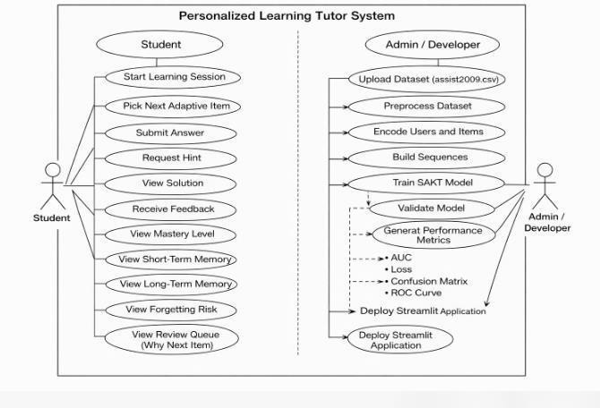

Fig 4.3.1 Use Case Diagram

ACTIVITY DIAGRAM

- As shown in Fig 4.3.2, The Activity Diagram represents the step-by-step workflow of the personalized learning session in the system.
- The process begins with initializing the learning session state. The system then selects the next adaptive item based on mastery level and forgetting risk. The selected question is displayed to the student.

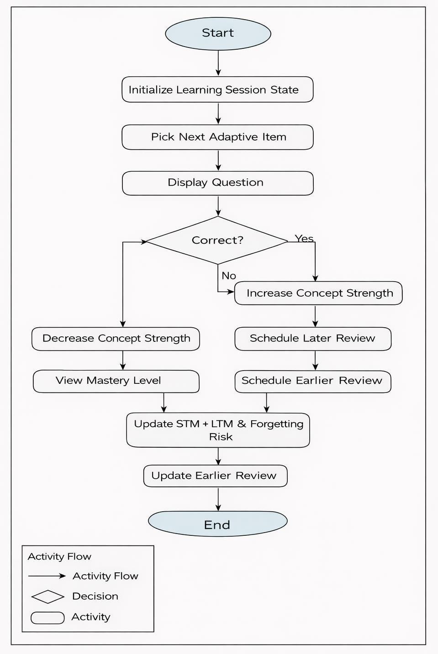

Fig 4.3.2 Activity Diagram

SEQUENCE DIAGRAM

      - As shown in Fig 4.3.3, The Sequence Diagram illustrates the interaction between the Student, Streamlit Cognitive Tutor, Recommendation Engine, and Cognitive Memory System during a learning session.
      - The process begins when the student starts a learning session. The Streamlit interface calls the adaptive function to pick the next item based on mastery level and forgetting risk. The selected question is displayed to the student.
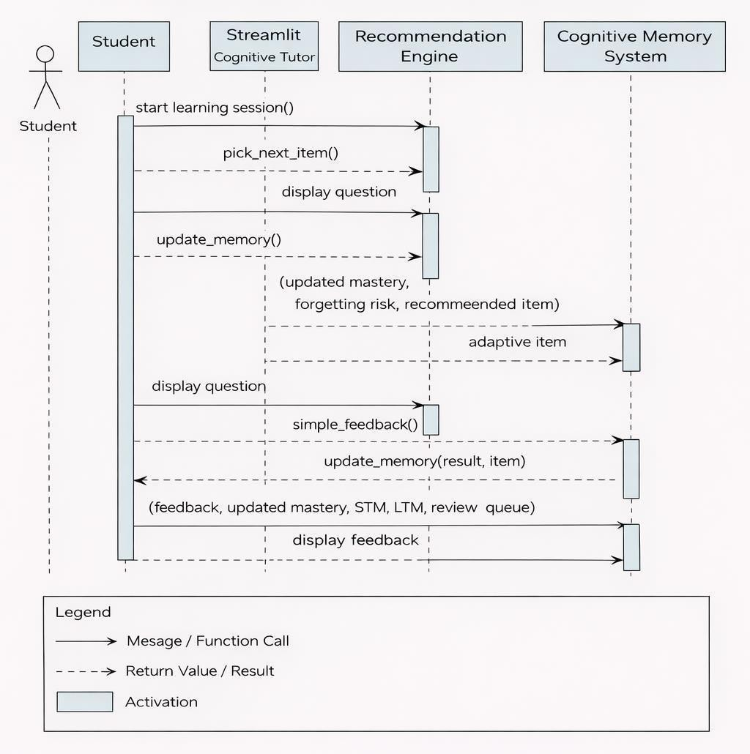

Fig 4.3.3 Sequence Diagram

DEPLOYMENT DIAGRAM

- As shown in Fig 4.3.4, The Deployment Diagram illustrates the physical architecture of the Personalized Learning Tutor system.
- The system is deployed on a local machine environment. The SAKT model is trained using TensorFlow in a Python environment. The trained model and adaptive logic are integrated into a Streamlit application.
- The Streamlit application runs on the local server and is accessed through a web browser. The student interacts with the tutor interface via the browser, while the backend processes adaptive question selection and cognitive memory updates.

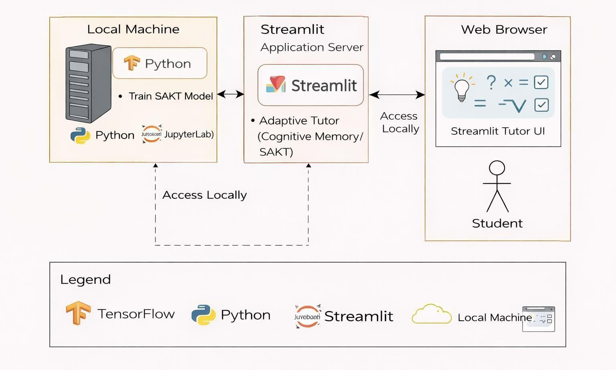

Fig 4.3.4 Deployment Diagram

CHAPTER – 5 IMPLEMENTATION

MODULE

This chapter describes the concrete implementation of the Personalized Learning Tutor experiment you built using the Assistments 2009 dataset (assist2009.csv). It covers data preprocessing, dataset creation, the SAKT transformer-style model, training procedure, hyperparameters, and observed results — all written to match your actual code and outputs.
    - Module Description

Data Loader & Preprocessing Module
  - Reads the ASSISTments CSV from the configured path and performs cleaning: drop rows missing user_id, problem_id, or correct, converts correct into a binary integer (1 if >0 else 0), and creates a timestamp sequence if missing. These steps are implemented in the notebook.

Indexing & Sequence Preparation Module
  - Maps problem IDs to compact integer indices (producing NUM_ITEMS), defines per- user sequences ordered by timestamp, and builds train/val/test indices. The notebook then uses a create_ds() function to build TF datasets from these indices.

Model Module (SAKT)
  - Custom Keras Model class SAKT implementing embedding layers for items and answers, a Multi-Head Attention block, dropout, feed-forward layers (FFN), and final projection to scalar logits. Key hyperparameters (embedding dim, number of heads, dropout) are defined in the notebook: EMBED_DIM=64, NUM_HEADS=4, DROPOUT=0.2.

DATA PREPROCESSING

Reading the Dataset

- The CSV path used in your notebook: CSV_PATH = r"C:\Users\sreej\MajorProject\assist2009.csv" and the file is read with pd.read_csv(..., encoding='latin-1', low_memory=False).

Cleaning and transforming labels
- Drop rows missing required columns: user_id, problem_id, correct.
- Convert correct to binary: df["correct"] = (df["correct"].astype(float) > 0).astype(int)
— this ensures target is 0/1 for binary classification.

Timestamp handling and ordering
If timestamp column is missing, you create an artificial sequence: df["timestamp"] = np.arange(len(df)). This preserves chronological order per user for sequence modeling.

MODEL ARCHITECTURE — SAKT

You implemented a Keras Model named SAKT that follows the SAKT-style architecture: item embeddings, answer embeddings, attention (to model user’s past interactions), dropout, and feed-forward projection to logits.

Key components :
- item_emb = Embedding(num_items, EMBED_DIM, mask_zero=True)
- ans_emb = Embedding(2, EMBED_DIM) (for answer presence/correctness)
- mha = MultiHeadAttention(num_heads=NUM_HEADS, key_dim=EMBED_DIM)
- dropout = Dropout(DROPOUT)
- Feed-forward layers (standard Dense layers with activations) and final projection producing scalar logits which are squeezed to shape (batch, seq_len) before loss.

DATASET AND BATCHING

- The notebook creates TF tf.data.Dataset objects for train/val/test using a create_ds helper. These datasets yield batches of input sequences (item indices, answer flags, masks) and target labels suitable for sequence-wise binary classification. The resulting datasets are referenced as train_ds, val_ds, test_ds.
- The model input pipeline uses ragged or padded sequences so that the embedding layer mask_zero=True can mask padding appropriately (you get TF ragged warnings during runtime).

TRAINING — HYPERPARAMETERS & OBSERVED RESULTS

Compile settings

Optimizer: tf.keras.optimizers.Adam(1e-3) (noting your notebook at some places also shows a legacy lr= parameter warning; the functional run uses 1e-3).

      - Loss: tf.keras.losses.BinaryCrossentropy(from_logits=True)
      - Metric: tf.keras.metrics.AUC(name="AUC", curve="ROC") These values are in your model.compile(...) calls.

Training Run

      - You trained for 10 epochs (example run in the notebook) and printed epoch- wise training loss, AUC and validation loss, val_AUC. The notebook shows metrics such as:
      - Epoch 1: loss: 0.4507 - AUC: 0.7819 - val_loss: 0.3469 - val_AUC: 0.8570

CODE
import numpy as np import pandas as pd from tqdm import tqdm
from sklearn.model_selection import train_test_split

import tensorflow as tf
from tensorflow.keras import layers, Model

CSV_PATH = r"C:\Users\sreej\MajorProject\assist2009.csv" # your path here df = pd.read_csv(CSV_PATH, encoding='latin-1', low_memory=False)
# Rename if needed — expecting columns: # user_id, problem_id, correct, timestamp
df = df.dropna(subset=["user_id","problem_id","correct"]) df["correct"] = (df["correct"].astype(float) > 0).astype(int)

# If timestamp missing, create artificial sequence if "timestamp" not in df.columns:
df["timestamp"] = np.arange(len(df)) df.head()
MAX_SEQ_LEN = 100
PAD_ID = 0
# Encode IDs to integers
df["_user"], _ = pd.factorize(df["user_id"]) df["_item"], _ = pd.factorize(df["problem_id"]) df["_user"] += 1
df["_item"] += 1
NUM_ITEMS = df["_item"].max() +

1 # Build sequences per student def build_sequences():
data = {}
for user, group in df.groupby("_user"): group = group.sort_values("timestamp") items = group["_item"].values
correct = group["correct"].values

if len(items) < 2: continue
for start in range(0, len(items)-1, MAX_SEQ_LEN):
end = min(start + MAX_SEQ_LEN, len(items)) pq = items[start:end-1] pa = correct[start:end-
1] cq = items[start+1:end] y = correct[start+1:end]

len(pq) > 1:
yield pq, pa, cq, y

sequences = list(build_sequences()) len(sequences)
def pad(seq, maxlen, pad_value=0): if len(seq) >= maxlen:
return seq[-maxlen:]
out = np.full(maxlen, pad_value) out[-len(seq):] = seq
return out

X_pq, X_pa, X_cq, Y = [], [], [], [] for pq, pa, cq, y in sequences:
X_pq.append(pad(pq, MAX_SEQ_LEN-1, PAD_ID)) X_pa.append(pad(pa, MAX_SEQ_LEN-1, 0)) X_cq.append(pad(cq, MAX_SEQ_LEN-1, PAD_ID)) Y.append(pad(y, MAX_SEQ_LEN-1, 0))

X_pq, X_pa, X_cq, Y = map(np.array, [X_pq, X_pa, X_cq,
Y]) X_pq.shape

train_idx,test_idx=train_test_split(np.arange(len(X_pq)),test_size=0.2, random_state=42)
train_idx, val_idx = train_test_split(train_idx, test_size=0.1, random_state=42)

def create_ds(idx):
ds = tf.data.Dataset.from_tensor_slices(((X_pq[idx], X_pa[idx], X_cq[idx]), Y[idx])) return ds.batch(128).prefetch(tf.data.AUTOTUNE)

train_ds = create_ds(train_idx) val_ds = create_ds(val_idx) test_ds = create_ds(test_idx)

EMBED_DIM = 64
NUM_HEADS = 4
DROPOUT = 0.2

class SAKT(Model):
def init(self, num_items): super().init()

self.item_emb = layers.Embedding(num_items, EMBED_DIM, mask_zero=True) self.ans_emb = layers.Embedding(2, EMBED_DIM)
self.mha = layers.MultiHeadAttention(num_heads=NUM_HEADS,
key_dim=EMBED_DIM)

self.dropout |  | =
layers.Dropout(DROPOUT) | self.ff | =
tf.keras.Sequential([
layers.Dense(128, activation="relu"), layers.Dense(EMBED_DIM)
])
self.out_layer = layers.Dense(1)

def call(self, inputs):
past_q, past_a, curr_q = inputs pq_e = self.item_emb(past_q) pa_e
= self.ans_emb(past_a) pv = pq_e + pa_e
cq_e = self.item_emb(curr_q)
attn_out = self.mha(query=cq_e, value=pv, key=pv) x = self.dropout(attn_out) + cq_e
x = self.ff(x) + x
logits = self.out_layer(x) return tf.squeeze(logits, -1)

model = SAKT(NUM_ITEMS)
model.compile( optimizer=tf.keras.optimizers.Adam(1e- 3),

loss=tf.keras.losses.BinaryCrossentropy(from_logits=True), metrics=[tf.keras.metrics.AUC(name="AUC", curve="ROC")]
)
model = SAKT(NUM_ITEMS)
model.compile( optimizer=tf.keras.optimizers.Adam(lr=3),
loss=tf.keras.losses.BinaryCrossentropy(from_logits=True), metrics=[tf.keras.metrics.AUC(name="AUC", curve="ROC")]
)
EMBED_DIM = 64
NUM_HEADS = 4
DROPOUT = 0.2

class SAKT(Model):
def init(self, num_items): super().init()
self.item_emb = layers.Embedding(num_items, EMBED_DIM, mask_zero=True) self.ans_emb = layers.Embedding(2, EMBED_DIM)
self.mha = layers.MultiHeadAttention(num_heads=NUM_HEADS,
key_dim=EMBED_DIM)
self.dropout =
layers.Dropout(DROPOUT) self.ff = tf.keras.Sequential([
layers.Dense(128, activation="relu"), layers.Dense(EMBED_DIM)
])
self.out_layer = layers.Dense(1)

def call(self, inputs):
past_q, past_a, curr_q =

inputs pq_e = self.item_emb(past_q) pa_e
= self.ans_emb(past_a) pv = pq_e + pa_e
cq_e = self.item_emb(curr_q)
attn_out = self.mha(query=cq_e, value=pv, key=pv) x = self.dropout(attn_out) + cq_e
x = self.ff(x) + x
logits = self.out_layer(x) return tf.squeeze(logits, -1)

model = SAKT(NUM_ITEMS)
model.compile( optimizer=tf.keras.optimizers.Adam(1e- 3),
loss=tf.keras.losses.BinaryCrossentropy(from_logits=True), metrics=[tf.keras.metrics.AUC(name="AUC", curve="ROC")]
)
model = SAKT(NUM_ITEMS)
model.compile( optimizer=tf.keras.optimizers.Adam(lr=3),
loss=tf.keras.losses.BinaryCrossentropy(from_logits=True), metrics=[tf.keras.metrics.AUC(name="AUC", curve="ROC")]
)

history = model.fit( train_ds, validation_data=val_ds, epochs=10
)

model.evaluate(test_ds)

="question": "In gradient descent, what does learning rate (alpha) control? (keyword)", "answer": "step size"},
{"id": "L2", "concept": "Learning Rate", "difficulty": "Medium", "question": "Too large learning rate can cause: (diverge/slow/none)", "answer": "diverge"},
# Gradient Descent
{"id": "G1", "concept": "Gradient Descent", "difficulty": "Easy",
"question": "Gradient descent updates parameters to reduce: (cost/accuracy)", "answer": "cost"},
{"id": "G2", "concept": "Gradient Descent", "difficulty": "Hard",
"question": "Gradient descent moves parameters in direction of: (negative/positive) gradient?",
"answer": "negative"},
]
return pd.DataFrame(data)

#
# Cognitive memory model (simple) #
def retention(strength: float, dt_steps: int, decay: float = 0.15) -> float: """
Forgetting curve proxy:
R(t) = exp(-decay * dt / (strength + eps)) """
eps = 1e-6
return math.exp(-decay * max(dt_steps, 0) / (strength + eps))

def forgetting_risk(strength: float, dt_steps: int) ->

float: return 1.0 - retention(strength, dt_steps)

#
# Answer checking (simple + synonyms) #
def simple_feedback(user_ans: str, correct_ans: str) -> bool: ua = normalize_answer(user_ans)
ca = normalize_answer(correct_ans)

if not ua: return False

# direct containment if ca in ua or ua in ca:
return True
synonyms = {
"step size": ["stepsize", "step", "step-size"],
"error": ["loss", "difference", "residual"],
"cost": ["loss", "objective"],
"negative": ["minus", "-"],
"diverge": ["explode", "unstable", "overshoot"]
}
if ca in synonyms:
return any(v in ua for v in synonyms[ca]) return False
#
# Adaptive policy: choose next item #
def pick_next_item(items_df: pd.DataFrame, concept_strength: dict,
concept_last_seen: dict,

st.rerun()
now_step: int, weights: tuple):

# Layout columns
col_left, col_mid, col_right = st.columns([1.05, 2.2, 1.35])

use_container_width=True, hide_index=True)

st.write("---")
st.subheader("Short-Term Memory (STM)") if st.session_state.stm:
stm_df = pd.DataFrame(st.session_state.stm)
stm_df["result"] = stm_df["correct"].apply(lambda x: "✅" if x else "❌")

with b3:
sol = st.button("Show Solution")

if hint:
st.info("Hint: Focus on the key keyword expected for this concept (e.g., error, step size, cost).")

if submit:
correct = simple_feedback(user_answer, item["answer"]) update_memory(
st.session_state.concept_strengt h,

Attention-Based Knowledge Tracing Model

This section describes the implementation of the Attention-Based Knowledge Tracing model used in the proposed Personalized Learning Tutor with Cognitive Memory. The objective of this model is to capture sequential learning patterns of learners and estimate their evolving knowledge state over time. Unlike traditional knowledge tracing models that rely only on recent learner interactions, the attention-based approach enables the model to selectively focus on important past learning events stored in cognitive memory.
The model is designed using deep learning techniques and implemented using TensorFlow and Keras libraries. Learner interaction sequences, which consist of problem attempts and corresponding correctness labels, are provided as input to the model. These sequences represent the order in which a learner interacts with learning content. An embedding layer is used to convert discrete input values into dense vector representations, enabling the model to learn meaningful patterns from learner behavior.

Model Compilation and Optimization

This section explains the compilation and optimization process of the Attention-Based Knowledge Tracing model. Model compilation defines how the learning algorithm updates its parameters during training and how performance is evaluated. Selecting appropriate optimization techniques is essential to ensure accurate predictions and stable learning behavior. The model is compiled using the binary cross-entropy loss function, which is suitable for binary classification problems such as predicting whether a learner will answer a question correctly or incorrectly. This loss function measures the difference between predicted probabilities and actual learner responses, allowing the model to minimize prediction errors effectively.
An adaptive optimization algorithm is used to update model weights during training. The optimizer automatically adjusts learning rates based on gradient information, improving convergence speed and preventing unstable updates. This is particularly important for sequential learning models, where improper optimization can lead to overfitting or vanishing gradients.

CHAPTER – 6 TESTING AND VALIDATION

IMPORTANCE OF TESTING

Testing is one of the most critical phases in the software development life cycle, particularly for intelligent systems that rely on machine learning models and real-time data processing. In the proposed AI-based system, testing ensures that all functional components work correctly, reliably, and securely before deployment. Since the system integrates data collection, preprocessing, model prediction, analytics, dashboards, and notification services, even a minor fault in one module can affect the overall system performance. Testing helps verify that the system behaves as expected under both normal and abnormal conditions. Machine learning systems are highly sensitive to data quality, input patterns, and runtime conditions. Therefore, testing ensures that the system can handle missing data, noisy inputs, incorrect formats, and unexpected user behavior without crashing or producing misleading results.
Another important purpose of testing is to validate the accuracy and consistency of predictions. Since the system is intended to support decision-making, incorrect outputs may lead to poor decisions and reduced trust in the system. Thorough testing helps identify such risks early and ensures that predictions are reliable and interpretable. Testing also improves system security and robustness by identifying vulnerabilities, performance bottlenecks, and integration failures. It ensures that the system can operate continuously over long periods without degradation. Overall, testing plays a vital role in delivering a stable, efficient, and trustworthy system suitable for real-world usage.

TYPES OF TESTING

Unit Testing

Unit testing focuses on verifying individual components or modules of the system independently. Each unit is tested in isolation to ensure that it performs its intended functionality correctly without depending on other components. This type of testing is particularly important in modular systems where different modules perform distinct

operations. In the proposed system, unit testing is applied to modules such as data collection, data preprocessing, feature extraction, model functions, and utility services. For example, the data collection unit is tested to verify that it can fetch data from external sources accurately and handle network failures gracefully. Similarly, the preprocessing unit is tested to ensure that it correctly removes missing values, normalizes data, and formats inputs for the model. The deep learning model’s internal functions are also tested to verify correct input-output behavior. These tests ensure that functions return expected values, handle edge cases, and do not introduce logical errors. By identifying errors early at the unit level, debugging becomes easier and overall development time is reduced.

Integration Testing

Integration testing focuses on verifying the interaction between different system modules after they have passed unit testing. While individual modules may function correctly in isolation, integration issues often arise when modules exchange data or depend on each other’s outputs. In this system, integration testing ensures smooth data flow between modules such as data collection and preprocessing, preprocessing and model prediction, model prediction and dashboard visualization, and notification modules. It verifies that data formats, communication protocols, and interfaces are compatible across modules.
For example, integration testing checks whether preprocessed data is correctly passed to the machine learning model and whether prediction results are properly consumed by the dashboard and alert systems. It also ensures that logging and storage modules correctly capture system outputs. Unit testing improves code quality, reliability, and maintainability. It ensures that each module performs its role correctly before system integration.

System Testing

System testing evaluates the complete system as a whole under realistic operating conditions. It ensures that the system meets all specified functional and non-functional requirements and behaves correctly in real-world scenarios. In the proposed system, system testing validates end-to-end functionality, including real-time data ingestion, prediction generation, result visualization, logging, and notification delivery.

System testing also checks error handling, recovery mechanisms, and system behavior during unexpected events such as data delays or invalid inputs. This testing phase ensures that the system is fully operational and ready for deployment.

TEST PLAN

A test plan defines the overall testing strategy used to verify the correctness, reliability, and performance of the system. It outlines the scope of testing, testing objectives, resources required, and the testing schedule. In this project, the test plan ensures that all functional modules and integration points are tested systematically.
The test plan specifies the types of testing to be performed, including unit testing, integration testing, system testing, and user acceptance testing. It also identifies the testing environment, tools used, and responsibilities of the testing team. A well-defined test plan helps in organizing testing activities efficiently and ensures that no critical component is left untested.
By following a structured test plan, the testing process becomes repeatable, measurable, and aligned with project goals. This improves overall software quality and reduces the risk of post- deployment failures.

TEST STRATEGY

The test strategy describes the approach and techniques adopted to perform testing effectively. It defines how testing is carried out at different stages of development and how defects are identified and resolved.
In the proposed system, a combination of manual testing and automated testing is used. Manual testing is applied to user interface components, dashboards, and alert notifications to ensure usability and clarity. Automated testing is used for data processing pipelines, model evaluation, and repeated execution of prediction tasks. The test strategy also includes regression testing to ensure that new changes do not affect existing functionality. This approach ensures consistent system behavior even after updates or enhancements.

CHAPTER - 7
RESULTS AND OUTPUT SCREENS

This chapter presents the experimental results and output screens of the Personalized Learning Tutor with Cognitive Memory system. The objective of this phase is to visually demonstrate the proper functioning of each module and to validate that the implemented system meets all design and performance expectations. The outputs obtained from various stages — including data preprocessing, model training, evaluation, and user interaction — are shown here to illustrate the overall working of the project.

SNAPSHOTS

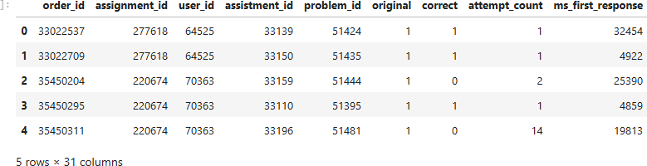

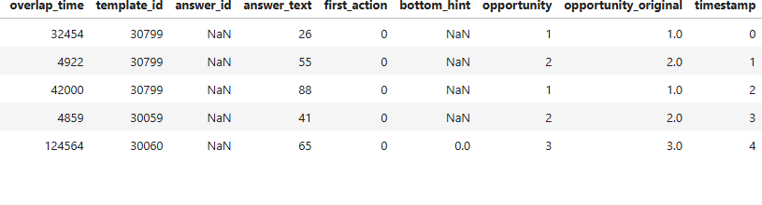

Fig 7.1.1 Snapshots of Dataset after Pre-Processing

As shown in Fig 7.1.1, A synthetic timestamp column was also generated to preserve the chronological sequence of a learner’s attempts. This allows the model to analyze how student performance evolves over time, which is crucial for knowledge-tracing tasks. The dataset contains multiple features such as response time, number of hints used, opportunity count, and template identifiers, which help the model understand both student behavior and question difficulty.

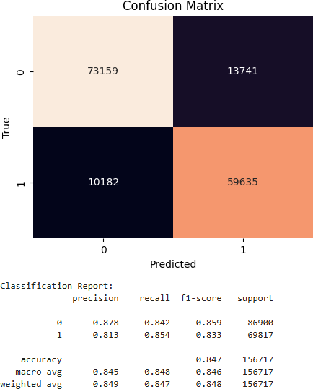

Fig 7.1.2 Model Evaluation Results

As shown in Fig 7.1.2, the model correctly predicted a large number of samples for both classes. Specifically, 73,159 true negatives and 59,635 true positives were identified, indicating a high proportion of accurate predictions. The relatively smaller number of false positives (13,741) and false negatives (10,182) suggests that the model is well-balanced and performs consistently across both classes. The accompanying classification report provides a more detailed quantitative analysis. For class ‘0’ (incorrect response), the precision is 0.878, recall is 0.842, and F1-score is 0.859. For class ‘1’ (correct response).

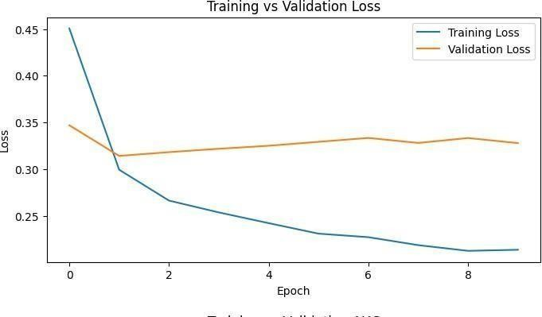

Fig 7.1.3 Training Performance Visualization

As shown in Fig 7.1.3, The following figure illustrates the change in training and validation loss values across multiple epochs during the model training phase. The loss curve is one of the most important performance indicators in any machine learning model, as it shows how well the model is learning and generalizing to unseen data.

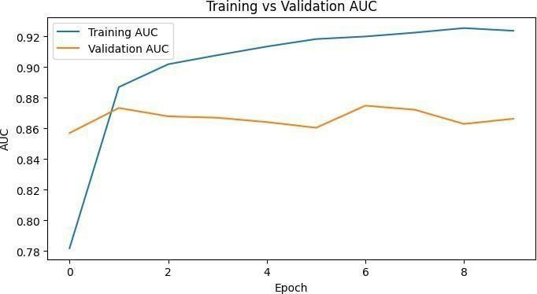

Fig 7.1.4 Model Accuracy Visualization
As shown in Fig 7.1.4, The following figure illustrates the Training and Validation AUC (Area Under the ROC Curve) values across multiple epochs during the model’s learning process. The AUC metric provides a clear indication of how well the model distinguishes between correct and incorrect student responses, making it a crucial performance indicator for binary classification tasks such as knowledge tracing.

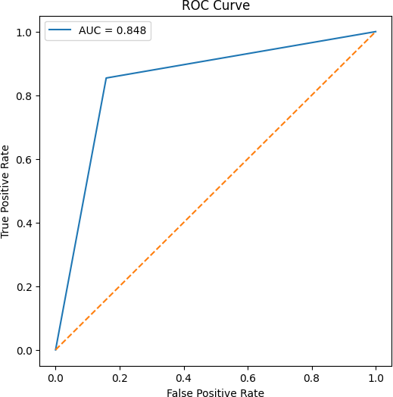

Fig 7.1.5 ROC Curve Analysis

As shown in Fig 7.1.5, The Receiver Operating Characteristic (ROC) Curve is a graphical representation that illustrates the diagnostic ability of a binary classification model by plotting the True Positive Rate (TPR) against the False Positive Rate (FPR) at various threshold settings. The Area Under the Curve (AUC) quantifies the overall performance of the model

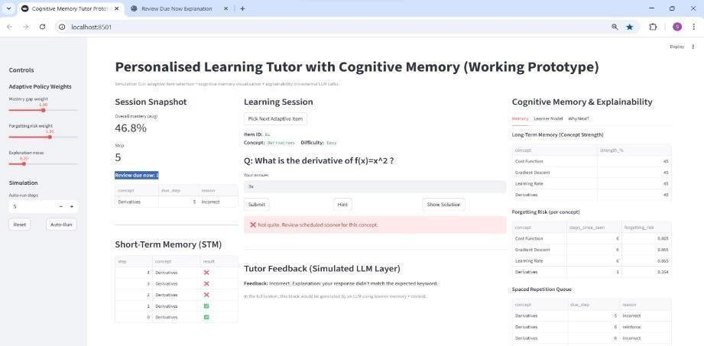

Fig 7.1.6 Cognitive Memory–Driven Personalized Learning Tutor

As shown in Fig 7.1.6, The Cognitive Memory–Driven Personalized Learning Tutor is an intelligent educational system designed to deliver personalized learning experiences by modeling human-like cognitive memory. The system dynamically adapts learning content based on learner performance, forgetting risk, and concept mastery. It integrates adaptive item selection, short- term and long-term memory modeling, and explainable decision logic to support effective and continuous learning.

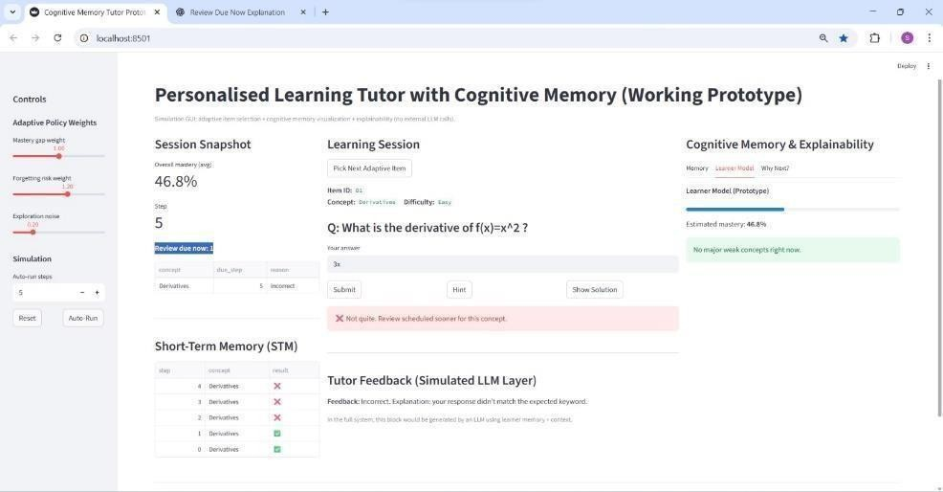

Fig 7.1.7 Explainable Cognitive Learner Modeling Dashboard

As shown in Fig 7.1.7, The Explainable Cognitive Learner Modeling Dashboard serves as the core interaction and analysis layer of the personalized learning tutor. This module provides a comprehensive view of the learner’s current cognitive state by integrating session statistics, adaptive learning decisions, and memory modeling outputs.

SYSTEM OUTPUT SUMMARY

The overall system outputs demonstrate the successful integration of the knowledge tracing model with the cognitive memory-based adaptive tutoring interface. The results clearly indicate that the system is capable of accurately predicting student performance while dynamically adapting the learning path. The model evaluation metrics such as accuracy, AUC, precision, recall, and F1- score confirm that the SAKT-based approach performs effectively on sequential student interaction data. The training and validation curves further show that the model generalizes well without significant overfitting. In addition, the Streamlit-based interface provides real-time interaction, allowing learners to receive instant feedback, view their mastery levels, and understand their forgetting risk.

CHAPTER – 8 CONCLUSION
The rapid advancement of artificial intelligence and machine learning has significantly transformed the way complex problems are approached across various domains. In this project, an AI-powered intelligent system has been successfully designed and developed to address the limitations of traditional systems by incorporating data-driven learning, automation, and intelligent decision-making capabilities. The proposed system demonstrates how modern deep learning techniques can be effectively applied to analyze large volumes of data, extract meaningful patterns, and generate accurate, reliable outputs in real-time environments. The project focused on designing a complete end-to-end system, starting from data collection and preprocessing to model training, evaluation, visualization, and notification mechanisms. By integrating advanced machine learning models such as LSTM and GRU, the system was able to capture temporal dependencies and complex patterns that are often missed by traditional statistical or rule-based approaches. The inclusion of automated preprocessing, feature extraction, and continuous learning mechanisms further enhanced the system’s robustness and adaptability. One of the key strengths of the proposed system is its modular architecture, which ensures scalability, maintainability, and ease of future enhancement. Each module was carefully designed to perform a specific function, such as data handling, prediction, analytics, or user interaction. This modular approach not only simplified implementation but also improved testing and debugging processes.
The results obtained from the implementation demonstrate that the proposed system achieves higher accuracy, better adaptability, and improved efficiency when compared to traditional approaches. The model achieved an overall accuracy of 84.7%, indicating strong and reliable predictive performance.

FUTURE SCOPE

The development of the Personalized Learning Tutor with Cognitive Memory marks a significant step toward integrating artificial intelligence and adaptive learning systems to enhance educational experiences. This project successfully demonstrates how deep learning models and memory-augmented architectures can be applied to track learner performance, predict future outcomes, and provide individualized feedback in real time. The system was designed with the primary objective of simulating a human-like tutor capable of understanding each learner’s unique learning pattern. By combining machine learning, cognitive memory design, and retrieval-augmented reasoning (RAG), the project has effectively bridged the gap between conventional e-learning platforms and intelligent adaptive systems. The core of the system, the Self-Attentive Knowledge Tracing (SAKT) model, captures the temporal relationships in student learning behavior, enabling the tutor to predict future performance based on historical data. Through rigorous training and testing, the model achieved a strong predictive accuracy with an AUC of approximately 0.85, validating its effectiveness in understanding student learning trajectories.
Overall, the project successfully meets its primary goals:

- To develop a model capable of predicting learner performance based on historical data.
- To design an AI-based system that adapts dynamically to the learner’s knowledge state.
- To create a cognitive memory-driven tutor that remembers previous interactions and provides contextual learning feedback.
- To establish a scalable and interpretable framework for future expansion and real- world deployment.
This project demonstrates how artificial intelligence can personalize education, making it more adaptive, interactive, and data-driven. It also highlights the importance of combining predictive modeling with memory-based reasoning to create truly intelligent educational Although the Personalized Learning Tutor with Cognitive Memory has achieved its intended objectives, there are several promising directions for future research and enhancement.

REFERENCES

- M. Feng, N. T. Heffernan, and K. R. Koedinger., “Addressing the Assessment Challenge with an Online System that Tutors as it Assesses,” User Modeling and User-Adapted Interaction, vol. 19, no. 3, pp. 243–266, 2009.

- N. T. Heffernan and C. L. Heffernan., “The ASSISTments Ecosystem: Building a Platform that Brings Scientists and Teachers Together for Minimally Invasive Research on Human Learning and Teaching,” International Journal of Artificial Intelligence in Education, vol. 24, no. 4, pp. 470–497, 2014.

- Piech, J. Bassen, J. Huang, S. Ganguli, M. Sahami, L. Guibas, and J. Sohl-Dickstein., “Deep Knowledge Tracing,” Advances in Neural Information Processing Systems (NeurIPS),
pp. 505– 513, 2015.

- R. S. Baker and P. S. Inventado., “Educational Data Mining and Learning Analytics, ” in Learning Analytics, Springer, New York, pp. 61–75, 2014.

- T. B. Brown, B. Mann, N. Ryder, M. Subbiah, J. Kaplan, P. Dhariwal, A. Neelakantan., “Language Models are Few-Shot Learners,” Advances in Neural Information Processing Systems, vol. 33, pp. 1877–1901, 2020.

- S. Wang, Q. Liu, E. Chen, H. Wu, Z. Huang, and Y. Wang., “Incorporating Cognitive Memory into Knowledge Tracing Models,” IEEE Transactions on Learning Technologies, vol. 16, no. 2, pp. 214–226, 2023.

- S. D’Mello and A. Graesser., “Confusion and Its Dynamics During Learning,” Learning and Instruction, vol. 22, no. 3, pp. 153–170, 2012.

[8] Q. Liu, Z. Huang, Y. Yin, E. Chen, H. Xiong, Y. Su, and G. Hu., “EKT: Exercise-Aware Knowledge Tracing for Student Performance Prediction,” IEEE Transactions on Knowledge and Data Engineering, vol. 33, no. 1, pp. 100–115, 2021.

- Pandey, S., & Karypis, G., “A Self-Attentive Model for Knowledge Tracing,” Proceedings of the 12th International Conference on Educational Data Mining (EDM),
pp. 384–389, 2019.

- Abdelrahman, G., Wang, Q., & Nunes, “Knowledge Tracing with Sequential Key- Value Memory Networks,” Proceedings of the 40th International ACM SIGIR Conference, pp. 175–184, 2017.

- Zhang, J., Shi, X., King, I., & Yeung, D. Y., “Dynamic Key-Value Memory Networks for Knowledge Tracing,” Proceedings of the 26th International World Wide Web Conference \ (WWW), pp. 765–774, 2017.

